Notes and Comments

About an article

- What an article is- It is the formal, peer-reviewed research report of original study findings, or a critical evaluation of existing work, published in an academic journal.
- Different kinds of papers - 1. Research paper/article: a. Entirely new research -system, model, solution. b. An improvement to an existing system, 2. Review Article: Analysis of existing techniques/methods/methodologies/applications to a particular problem in a particular topic/area based on your intuition, 3. Methodology article, 4. Software article, 5. Perspectives, 6. Comments.
- Format of a research paper/article- 1. Title, 2. Abstract, 3. Introduction, 4. Literature review, 5. Proposed Architecture and Proposed Methodology including materials, technologies, components and applications, Results and Interpretation, Conclusion, Future Work, References.
- Title - finalized, should be able to explain what your paper is about.
- Abstract - should be a brief description about the entire project from general to specific. Word format also should be taken care- based on the journal, maybe from 150-300 words depending on the journal that you choose.
- Introduction- Should be elaborate and descriptive, From the general background, how you arrived, till the specifics of your project.
- Literature review- Extensive Analysis of existing works, systems, techniques, models, software applications and others.
- Methodology - Explain the flow, about your proposed or improved solution to the problem.

About Review Paper
Entirely Based on the extensive review of literature, gives an idea on: what topic you are researching on, getting a finalized title, what the existing methods, techniques and systems are.
Format- 1. Title, 2. Abstract, 3. Introduction, 4. Body (May contain methodologies used in significantly related papers, Results, Challenges identified, Tabular structure of the literature survey, General discussion-interpretation), 5. Conclusion, 6. References.
- Some journals are specific about review papers.
- This is entirely based on your intuition.

About Journals
- There are different kinds of journals. There's a unique paper format for every journal and based on that, the structure of the paper should be modified.
- The first step in selecting a journal for publishing should be to check its aim, scope, and whether it is indexed in Scopus or SCIE.
- The Literature review is inextricably linked to every major component of your research- your research topic, figuring out your final title, for a review paper.
A Literature Review contains the following parameters:
SNO, Title of the paper, Year it was published, Dataset/Data source used, Algorithms/Techniques used, Achievements/Work Done, Limitations/Shortcomings

For example:

Sno | Title of the paper | Year | Dataset/Data source used | Algorithms/Techniques used | Achievements/Work Done | Limitations/Shortcomings
1
2

-> Only Research Articles from reputed journals can be taken for literature review. Conference papers should be avoided.

Following research papers/articles can be taken from the following list of reputed journals:
- Springer
- Elsevier
- IEEE
- Web of Science (WOS)
- Scopus indexed journals (Journal can be checked whether it's from scopus or not from the following website: https://www.scopus.com/sources.uri)
- Taylor and Francis
- Wiley
- ACM and ACS
- Nature

Research article Details
The research article consists of the following components. The representation may change depending on the journal and depending on how we present our work in the article.
1. Abstract (summarized version of the entire project from background research)
2. Introduction (basically includes background research into the topic, what existing problems are present in your topic, and how you're going to solve them with your proposed architecture)
3. Literature review of at least 10 papers (summary of all 10 papers with citations or taking significantly related papers out of the base papers selected and writing a basic summary of each with citations included... Outlook is based on the journal selected)
4. Proposed Architecture (detailed explanation of your proposed architecture, every step and every module, explaining how you solved the problem and how it's different from other existing architectures, and attachment of the picture of your proposed architecture diagram)
5. Results (list out in detail, the results that you've achieved)
6. Discussion (Interpretation of the results)
7. Conclusion
8. Future Work (based on the journal, you need to include it) (We'll include it).
9. References (citations included, the reference format is decided by the journal)

Important points to be kept in mind and performed while doing the implementation
- Implementation should be performed on a module wise basis - this is for a clearer understanding of the end-to-end pipeline/workflow you are constructing.
- If you are constructing a large or sophisticated or a more complex AI model (it may be ML, DL, or LLMs) for your study, you should implement the following: A. GPU optimizations, and B. Version control (Google drive or any other similar application should be connected for version control).
GPU optimizations (apply to our proposals if necessary)
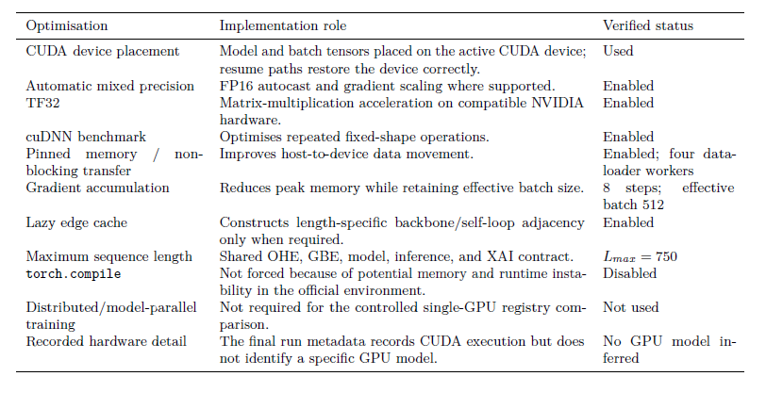
- Check for any imbalances in the dataset used. If there is indeed an imbalance- class balancing should be performed first before proceeding with model training.

- A generalized modular based workflow (end-to-end pipeline) that should be followed in both our proposals (and in any Machine Learning and Deep Learning Projects) is as follows:

Generalized ML/DL Research Pipeline
┌──────────────────────────────┐
│ 1. DATA ACQUISITION & │
│ FEATURE ENGINEERING │
└──────────────┬───────────────┘
↓
┌──────────────────────────────┐
│ 2. DATA PREPARATION & │
│ EXPERIMENTAL DESIGN │
└──────────────┬───────────────┘
↓
┌──────────────────────────────┐
│ 3. MODELLING, TRAINING & │
│ MODEL SELECTION │
└──────────────┬───────────────┘
↓
┌──────────────────────────────┐
│ 4. INFERENCE, EVALUATION & │
│ EVIDENCE │
└──────────────────────────────┘

1. DATA ACQUISITION & FEATURE ENGINEERING
M1 — Environment and Reproducibility
- Define project objective and ML/DL task.
- Fix random seeds.
- Record software/library versions.
- Define runtime configuration.
- Establish data/version control.
- Define experiment and output directories.
↓
M2 — Raw Data Acquisition
Possible sources:
- Public datasets
- Institutional datasets
- Experimental data
- Databases/APIs
- Multiple independent datasets
For every dataset:
- Acquire/download data.
- Preserve an immutable raw copy.
- Record provenance.
- Verify file integrity.
- Identify samples, features, labels and metadata.
↓
M3 — Data Quality and Feature Engineering
- Remove or document corrupted/invalid records.
- Check duplicates.
- Harmonize variable names and units.
- Construct relevant derived features.
- Define targets/labels.
- Generate validity masks where required.
- Preserve sample identifiers.
For multiple datasets:
Dataset A ──→ Dataset-A processing ──┐
├──→ Harmonized dataset
Dataset B ──→ Dataset-B processing ──┘
Output of Phase 1:
Clean, traceable dataset(s) containing validated input variables/features and clearly defined prediction targets.

2. DATA PREPARATION & EXPERIMENTAL DESIGN
M4 — Exploratory Data Analysis
Study:
- Dataset dimensions
- Feature distributions
- Target distributions
- Missingness
- Outliers
- Correlations
- Dataset/domain shift
- Class imbalance
- Subgroup characteristics
For multiple datasets, explicitly compare their distributions.
↓
M5 — Task and Target Contract
Define exactly what the model predicts.
Examples:
Classification:
X → class label

Regression:
X → continuous value

Multi-task:
X → {classification, regression, ...}
Also define:
- Inclusion/exclusion rules
- Missing-target handling
- Valid samples for each task
- Loss masking if necessary
↓
M6 — Leakage-Controlled Data Splitting
Create:
Training set
Validation set
Test set
Depending on the problem, use:
- Stratified splitting
- Group-aware splitting
- Temporal splitting
- Subject-wise splitting
- Patient-wise splitting
- Scaffold/protein/entity-wise splitting
- Cross-validation
Critical rule:
The test set must remain untouched during preprocessing, model development, hyperparameter optimization and model selection.
↓
M7 — Data Representation
Two generic branches can be retained.
M7A — Raw/Unstructured Representation
For DL:
Raw data
↓
Encoding / tokenization / transformation
↓
Embedding
↓
Neural representation
Examples:
- Text → tokens/embeddings
- Protein sequence → residue encodings
- Images → tensors
- Time series → windows
- Audio → spectrograms
- Graphs → node/edge representations
M7B — Structured Feature Processing
For tabular or engineered features:
- Scaling
- Normalization
- Transformation
- Categorical encoding
- Feature selection
- Dimensionality reduction where justified
Fit preprocessing only using training data.
↓
M8 — Imbalance and Sampling Strategy
Where applicable:
- Class weights
- Weighted sampling
- Balanced mini-batches
- Oversampling
- Undersampling
- Appropriate augmentation
Again, transformations should be learned from the training partition only.

3. MODELLING, TRAINING & MODEL SELECTION
M9 — Candidate Model Registry
Instead of immediately selecting one algorithm, define candidate models.
For example:
Classical ML
- Logistic Regression
- Random Forest
- SVM
- XGBoost/Gradient Boosting
Deep Learning
- MLP
- CNN
- RNN/LSTM
- Transformer
- GNN
- Hybrid architectures
Task-specific models
- Transfer-learning models
- Multimodal models
- Multi-task models
- Physics-informed models
- Knowledge-guided models
Also define:
- Hyperparameters
- Optimizer
- Learning rate
- Batch size
- Loss functions
- Seeds
- Training epochs
- Early stopping rules
↓
M10 — Model Training
Training Data
↓
Candidate Models
↓
Training
↓
Validation
↓
Checkpointed Models
Optional components:
- Cross-validation
- Hyperparameter optimization
- Transfer learning
- Pretraining → fine-tuning
- Multi-dataset training
- Domain adaptation
↓
M10A — Validation-Only Model Selection
This is one of the most important concepts from your original pipeline and should be preserved.
Models should be selected using validation data only.
For example:
[
Score_{selection}
w_1 Metric_1+
w_2 Metric_2+\cdots+w_n Metric_n
]
Selection may consider:
- Accuracy/AUROC/F1
- MAE/RMSE/(R^2)
- Calibration
- Robustness
- Generalization
- Model complexity
Then:
Candidate models
↓
Validation comparison
↓
Best model selected
↓
Architecture + checkpoint frozen
↓
Test set opened
This creates a much more defensible research design than choosing the model based on test performance.

4. INFERENCE, EVALUATION & EVIDENCE
M11 — Frozen-Test Prediction
Use the selected model to generate predictions for the untouched test set.
Frozen model
+
Locked test data
↓
Raw predictions
Preserve raw predictions before any calibration or post-processing.
↓
M11.5 — Optional Calibration/Post-processing
Where appropriate:
- Probability calibration
- Threshold optimization
- Bias correction
- Output transformation
These procedures must not be fitted using test labels.
↓
M12 — Locked Test Evaluation
Choose metrics appropriate to the task.
Classification
- Accuracy
- Balanced Accuracy
- Precision
- Recall/Sensitivity
- Specificity
- F1
- AUROC
- AUPRC
- MCC
- Calibration metrics
Regression
- MAE
- RMSE
- (R^2)
- Pearson/Spearman correlation
- Residual analysis
Statistical Evidence
Add:
- Confidence intervals
- Bootstrap analysis
- Statistical comparisons
- Effect sizes where relevant
For example:
Model prediction
↓
Primary metrics
↓
Confidence intervals
↓
Statistical evidence
↓
M13 — Explainability and Interpretation
Depending on model/data type:
- SHAP
- Permutation importance
- Feature importance
- Integrated Gradients
- Attention analysis
- Saliency maps
- Partial dependence
- Counterfactual explanations
Interpretability should answer:
What information caused the model to make its prediction?
rather than merely displaying plots.
↓
Direct Comparator / Baseline Comparison
Compare the proposed method against:
- Simple statistical baseline
- Standard ML model
- Standard DL architecture
- Existing benchmark method
- Published method where reproducible
This establishes whether the proposed complexity actually provides value.
↓
External / Contextual Validation
If additional independent data exist:
Primary test evaluation
+
Independent dataset
↓
External generalization evidence
Possible forms:
- External dataset
- Different institution
- Different population
- Different acquisition platform
- Different time period
- Published benchmark values
↓
Robustness and Error Analysis
Evaluate:
- Subgroups
- Distribution shifts
- Noise sensitivity
- Missing features
- Different seeds
- Failure cases
- Misclassified samples
- Out-of-distribution examples
↓
Future Extensions / Deployment
Examples:
- Larger external validation
- Prospective evaluation
- Additional datasets
- Model optimization
- Deployment
- Real-world testing
- Multimodal extension
- Longer/larger input support

Final generalized structure
The entire generalized figure can therefore use this structure:
1. DATA ACQUISITION
& FEATURE ENGINEERING
│
├─ M1 Environment & reproducibility
├─ M2 Raw data acquisition & provenance
└─ M3 Quality control & feature engineering / Feature selection or both
│
▼
2. DATA PREPARATION
& EXPERIMENTAL DESIGN
│
├─ M4 Exploratory data analysis
├─ M5 Task / target definition
├─ M6 Leakage-controlled splitting
├─ M7A Input representation / encoding / embedding
├─ M7B Structured-feature preprocessing
└─ M8 Class balancing / sampling
│
▼
3. MODELLING
& MODEL SELECTION
│
├─ M9 Candidate model registry
├─ M10 Model training / tuning
├─ M10 Optional transfer learning / adaptation
└─ VALIDATION-ONLY MODEL SELECTION
│
▼
FREEZE BEST MODEL
│
▼
4. INFERENCE
& EVIDENCE
│
├─ M11 Raw prediction generation
├─ M11.5 Optional calibration
├─ M12 Locked test evaluation
├─ M13 Explainability / interpretation
├─ Baseline / comparator evaluation
├─ External validation
├─ Robustness & error analysis
└─ Future extensions / deployment
Most important principle
The generalized scientific workflow is essentially:
Data → Prepare → Split → Represent → Train → Validate → Select → Freeze → Test → Explain → Compare → Validate externally
with a strict separation between:
development evidence — training and validation
and
final evidence — untouched test data and external validation.

Tools to have

- Everyone should create and have a ORCID ID: a. a special 16-digit code that uniquely identifies you as a researcher. This is to ensure that the correct author of that particular article is found. You can connect the published article to your unique ID. You can register and get the ID by going to this site: https://orcid.org/register and then link your personal and VIT student emails with this ID.

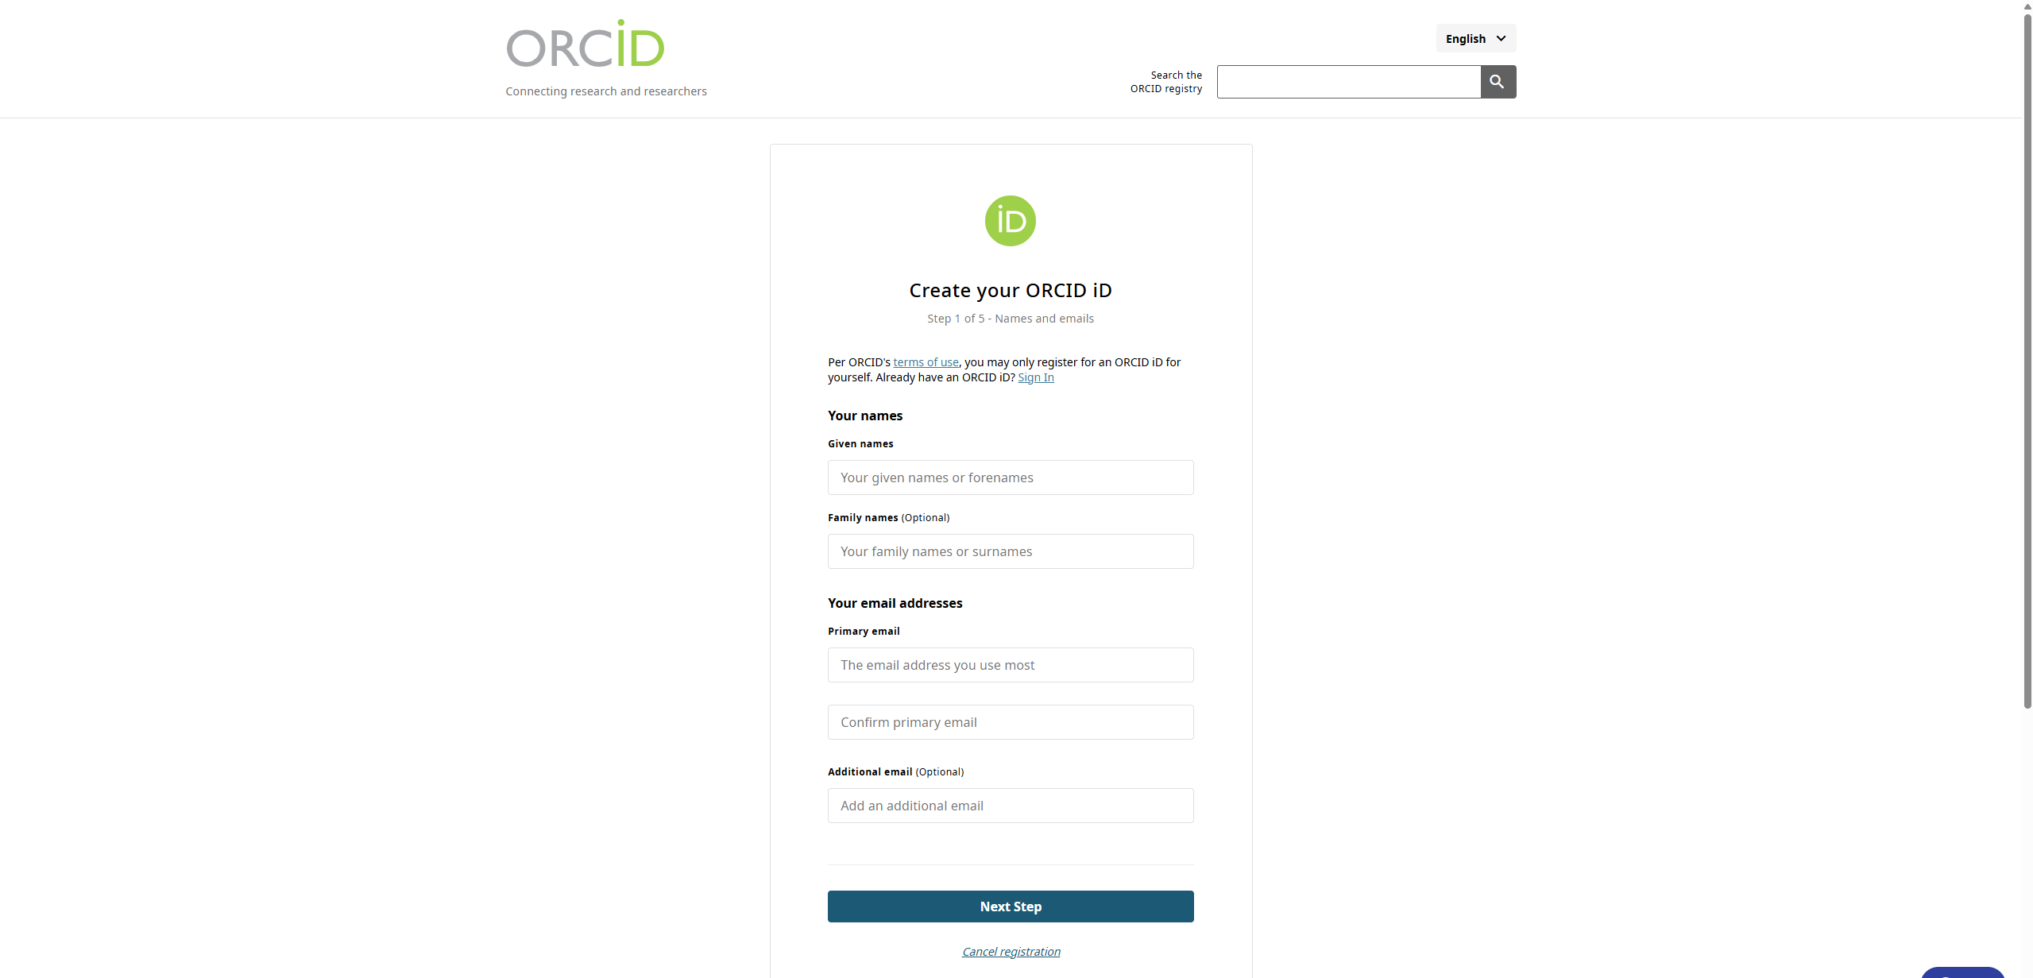

- Everyone should have an overleaf account to write the article. You can register and access it by using your vit student account. The website: https://www.overleaf.com/

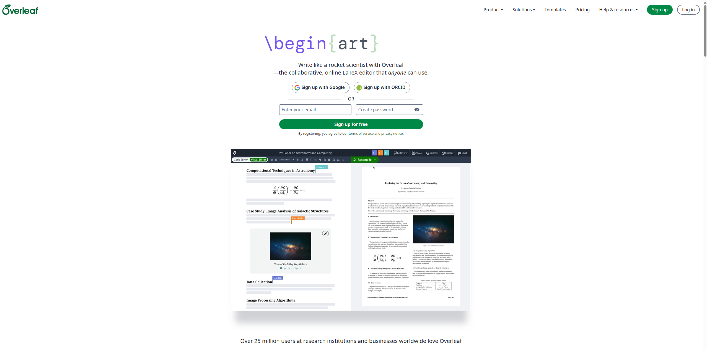

- Everyone should have accounts and access to the following AI tools: a. Chatgpt, b. Perplexity, c. Gemini, d. Claude, e. Researchrabbit
ResearchRabbit is completely free and easy to use. You can use your VIT student login credentials to register and login. The website: https://www.researchrabbit.ai/


- NOTE: Everyone must have all listed tools for efficient completion of tasks. ChatGPT is used for general prompting, web search, deep research, writing, coding and development of ideas, proposals and papers, Perplexity is used for existing patent retrieval, verification of data/information given by Gemini or ChatGPT or Claude, Gemini is used for coding, development of figures (for the paper), simple in-depth analysis of information retrieved from other AI tools, Claude is mainly used for coding, development of workflow and clean figure development, and Researchrabbit is mainly used for literature review.
- Workflow of using AI tools: Gathering of information, novelty, workflow, sample code using chatgpt, verification of that information (scientifically and research oriented) using perplexity, performing literature review using Researchrabbit, improvement of coding (taken from chatgpt-use only if necessary), development of idea for the figures (for the paper), simple in-depth analysis of information from perplexity using Gemini, and finally develop the code for each module for the implementation, and clean figure development using the ideas developed from Gemini using Claude.
- Your intuition and analysis should be controlling the outcome of these AI tools.
- Everyone should remember three key words- Feasible, Implementable and Defensible. Any and every proposal, project, and paper we develop should be Feasible, implementable and defensible.

- Everyone should have either Google Colab or Jupyter notebook (from Anaconda) for the implementation.

Comments from Aju sir
  - Two proposals
- Digital Twin
- Understand, make it clear and elaboratewhat we are trying to accomplish with this digital twin and the novelty we're proposing.
- Since the machine related details are not available and is generalized, are: a. any specific machine related Digital Twin datasets available? b. any other specific digital twin dataset is available? List them out.
- Novelty is good but needs to be more elaborate on how and where we're going to use it.

- AI Resume Screening
-> Motivation: AI bots are being used to screen and shortlist candidates for different job roles without human intervention. This project is to understand how and why AI bots/systems are being used to screen candidates.
- Policy, Preferences (from the company/companies), qualifications and skillset should be understood.
- While developing any model in this area, the architecture and dataset/data used for the training for the model should be in such a way that it should be able to analyze, classify and shortlist the candidates for any particular job role. The model should follow a generalized approach -should work for all outcomes and any test data that you give.
- How does the developed model process and read the required data/information from the data (assuming resumes, CVs, experience, LORs)? Any particular technique or method to be used here?
- Neurosymbolic AI is the preferred approach to guide the model to screen, read, and shortlist the candidate – since an Integrated Neurosymbolic Machine learning or an Integrated Neurosymbolic deep learning model is better than a usual ML or DL model.
- How do you screen a candidate for a job role in a particular company?
- Understand how different AI bots/resume screening systems from different companies’ screen candidates.
- Could LLMs or SLMs be used in this project?

